***ANDROID PROGRAMMING IA-2***

***Members:***

***Noor Fatima Kas (T23071) &***

***Afraa Fakih (T23014)***

***CLASS: S.Y.B.Sc-IT***

***SUBJECT: ANDROID MOBILE PROGRAMMING.***

***TOPIC: Q-MOTION***

***[RANDOM QUOTE GENERATOR]***

**Activity_main.xml:**

<RelativeLayout xmlns:android="<http://schemas.android.com/apk/res/android>"

<!--RelativeLayout is used to arrange elements relative to each other..-->

xmlns:tools="http://schemas.android.com/tools" android:layout_width="match_parent"  
android:layout_height="match_parent"

android:padding="16dp"  
 android:background="@drawable/main_bg2"> <!--/sets an image named main_bg2 as the background→  
  
 <TextView  
 android:id="@+id/appTitle"  
 android:layout_width="wrap_content" <!-- keeps the width & height of the   
 android:layout_height="wrap_content". text as big as the content →  
 android:text="@string/q_motion"

<!-- @string/q_motion means the text is stored in strings.xml. →  
 android:textColor="#162554"  
 android:textSize="24sp"  
 android:layout_marginLeft="140dp"  
 android:layout_marginTop="20dp"  
 android:layout_marginBottom="16dp" />

<!--Displays the app name ("Q-MOTION"). →

<!-- Emotion Buttons to help the user select their mood -->  
  
 <Button  
 android:id="@+id/happyButton"  
 android:layout_width="wrap_content"  
 android:layout_height="wrap_content"  
 android:layout_alignParentLeft="true" <!-- aligned to left →  
 android:layout_marginLeft="45dp" <!-- distance from left margin →  
 android:layout_marginTop="145dp" <!-- distance from top margin →  
 android:text="@string/happy" <!-- button text from string.xml→  
 />  
  
 <Button  
 android:id="@+id/sadButton"  
 android:layout_width="wrap_content"  
 android:layout_height="wrap_content"  
 android:layout_below="@id/appTitle"<!--sets the button below appTitle→  
 android:layout_marginLeft="45dp" <!-- distance from left margin →  
 android:layout_marginTop="245dp"<!-- distance from top margin →  
 android:text="@string/sad" /> <!-- button text from string.xml→  
  
 <Button  
 android:id="@+id/angryButton"  
 android:layout_width="wrap_content"  
 android:layout_height="wrap_content"  
 android:layout_below="@id/appTitle"  
 android:layout_marginTop="245dp" <!-- distance from top margin →  
 android:layout_marginRight="35dp" <!-- distance from right margin →  
 android:layout_alignParentRight="true" <!-- alignmen to right → android:text="@string/angry" /> <!-- button text from string.xml→

<Button  
 android:id="@+id/overwhelmedButton"  
 android:layout_width="wrap_content"  
 android:layout_height="wrap_content"  
 android:layout_below="@id/appTitle"  
 android:layout_marginTop="70dp" <!-- distance from top margin → android:layout_alignParentRight="true" <!-- alignmen to right →  
 android:layout_marginRight="15dp" <!-- distance from right margin →  
 android:text="@string/overwhelmed" /> <!-- button text from string.xml→</RelativeLayout>

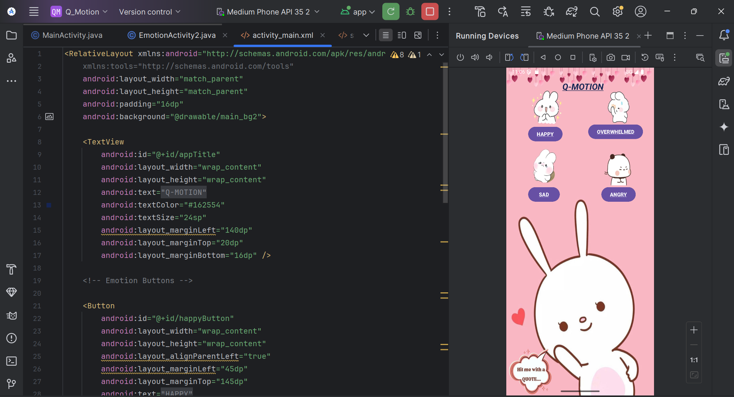

**Mainactivity.java:**

package com.example.q_motion;  
  
import android.content.Intent;  
import android.os.Bundle;  
import android.widget.Button;  
import androidx.appcompat.app.AppCompatActivity;  
  
public class MainActivity extends AppCompatActivity {  
  
 @Override  
 protected void onCreate(Bundle savedInstanceState) {  
 super.onCreate(savedInstanceState);  
 setContentView(R.layout.*activity_main*);  
<!-- This onCreate() method runs when the app starts. →  
 Button happyButton = findViewById(R.id.*happyButton*);  
 Button sadButton = findViewById(R.id.*sadButton*);  
 Button angryButton = findViewById(R.id.*angryButton*);  
 Button overwhelmedButton = findViewById(R.id.*overwhelmedButton*);

<!-- This finds the four buttons (happyButton, sadButton, etc.) in the XML file.

Now, we can add click actions to them. →

// Set click listeners for each button  
 happyButton.setOnClickListener(v -> openEmotionActivity("happy"));  
 sadButton.setOnClickListener(v -> openEmotionActivity("sad"));  
 angryButton.setOnClickListener(v -> openEmotionActivity("angry"));  
 overwhelmedButton.setOnClickListener(v -> openEmotionActivity("overwhelmed"));  
 }

<!-- When a button is clicked, it calls the openEmotionActivity() method and passes the emotion type as a string.-->  
  
 private void openEmotionActivity(String emotionType) {  
 Intent intent = new Intent(MainActivity.this, EmotionActivity.class);  
 intent.putExtra("emotionType", emotionType);  
 startActivity(intent);  
 }  
}

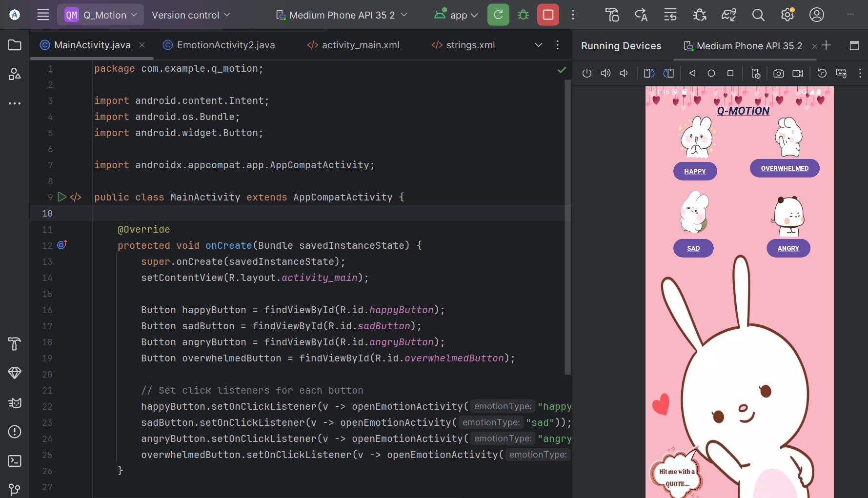

**Activity_emotion.xml:**

<RelativeLayout xmlns:android="http://schemas.android.com/apk/res/android"

android:id="@+id/mainLayout"

android:layout_width="match_parent"

android:layout_height="match_parent"

android:padding="16dp"

android:background="@drawable/default_bg1">

<TextView

android:id="@+id/quoteTextView"

android:layout_width="match_parent"

android:layout_height="wrap_content"

android:gravity="center"

android:padding="16dp"

android:layout_marginTop="320dp"

android:background="#80000000"

android:text="Your Quote Appears Here!"

android:textColor="#FFFFFF"

android:textSize="22sp"

android:textStyle="italic" />

<Button

android:id="@+id/generateQuoteButton"

android:layout_width="wrap_content"

android:layout_height="wrap_content"

android:layout_marginTop="450dp"

android:layout_centerHorizontal="true"

android:text="Generate Quote" />

</RelativeLayout>

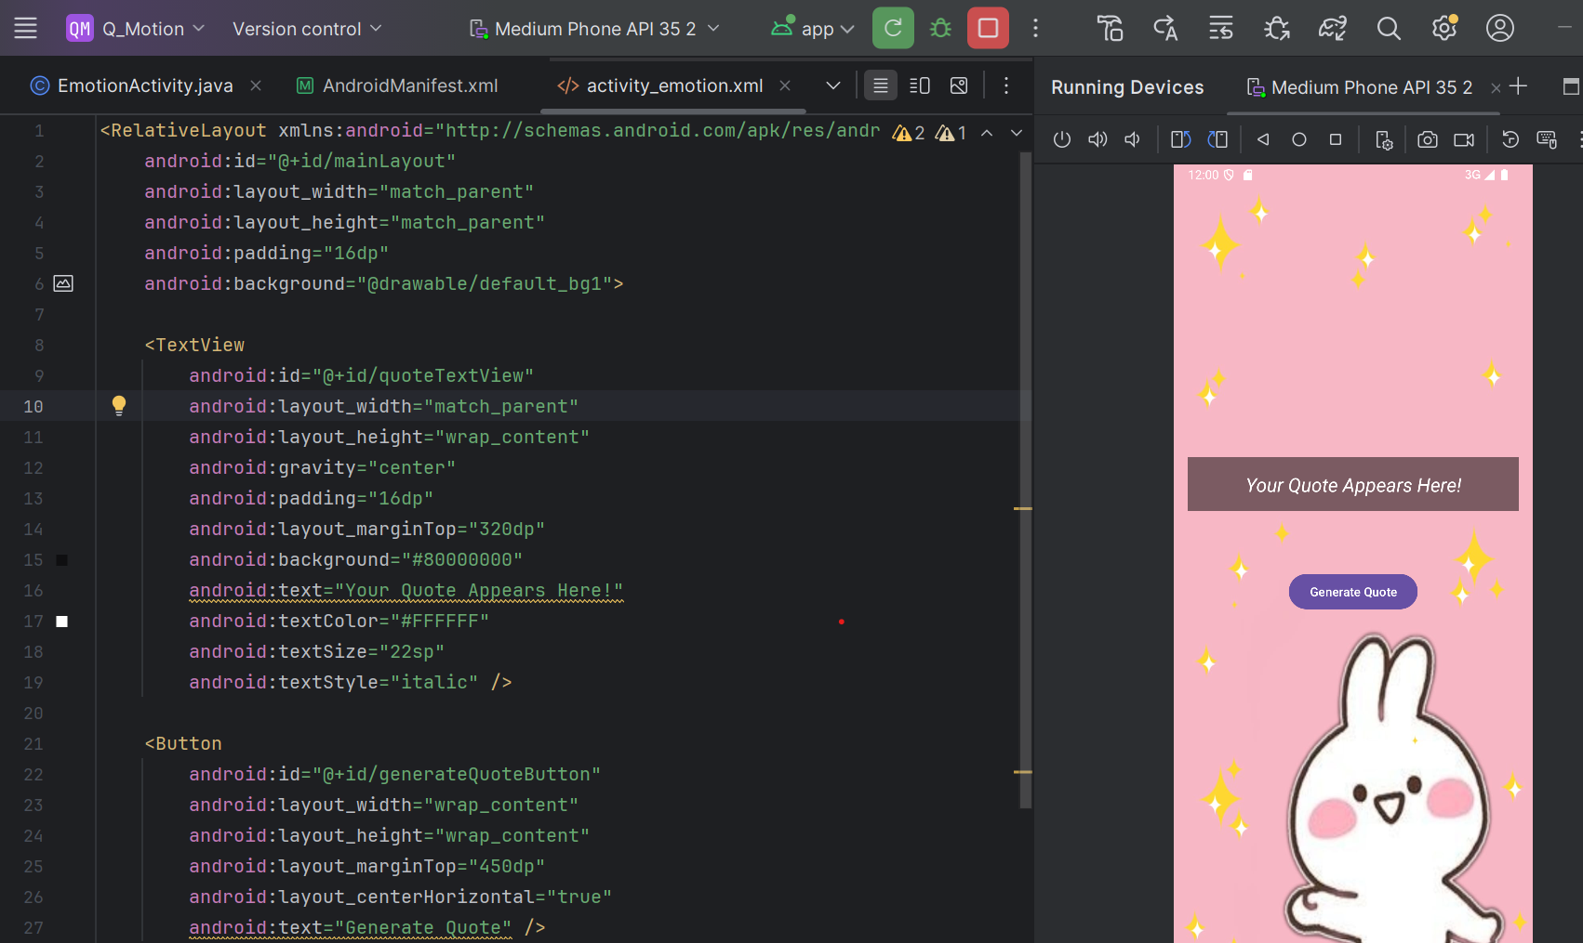

**Emotionactivity.java:**

package com.example.q_motion;  
  
import android.annotation.SuppressLint;  
import android.content.Intent;  
import android.os.Bundle;  
import android.widget.Button;  
import android.widget.RelativeLayout;  
import android.widget.TextView;  
import androidx.appcompat.app.AppCompatActivity;  
import java.util.Random;

public class EmotionActivity extends AppCompatActivity {  
  
 private String emotionType;  
 private String[] quotes;  
 private int[] backgrounds;  
  
 @Override  
 protected void onCreate(Bundle savedInstanceState) {  
 super.onCreate(savedInstanceState);  
 setContentView(R.layout.*activity_emotion*);  
  
 TextView quoteTextView = findViewById(R.id.*quoteTextView*);  
 Button generateQuoteButton = findViewById(R.id.*generateQuoteButton*);  
 @SuppressLint({"MissingInflatedId", "LocalSuppress"}) RelativeLayout layout = findViewById(R.id.*mainLayout*);  
  
 // Get emotion type from Intent  
 Intent intent = getIntent();  
 if (intent.hasExtra("emotionType")) {  
 emotionType = intent.getStringExtra("emotionType");  
 }  
  
 // Define quotes and backgrounds based on emotion  
 switch (emotionType) {  
 case "happy":  
 quotes = new String[]{  
 "Happiness is not out there, it's in you.",  
 "Enjoy the little things, for one day you may look back and realize they were the big things.",  
 "Happiness is contagious—spread it everywhere you go!",  
 "A smile is the prettiest thing you can wear.",  
 "The best way to multiply your happiness is to share it with others.",  
 "Wake up with determination. Go to bed with satisfaction." ,  
 "Your joy is your superpower—never let anyone take it away.",  
 "Every moment is a fresh beginning—embrace it with a smile!"  
 };  
 backgrounds = new int[]{R.drawable.*bg1*, R.drawable.*bg2*, R.drawable.*bg8*, R.drawable.*bg4*, R.drawable.*bg3*, R.drawable.*bg6*, R.drawable.*bg26*, R.drawable.*bg5* };  
 break;  
  
 case "sad":  
 quotes = new String[]{  
 "It’s okay to not be okay. Just don’t stay there.",  
 "Sadness is like the ocean; it comes in waves, but it also recedes.",  
 "You are not alone, even when it feels like you are.",  
 "No storm lasts forever—the sun always shines after the rain.",  
 "You’re stronger than you think, and you’ve already survived so much.",  
 "Healing takes time, and you’re allowed to take all the time you need.",  
 "Crying is not a sign of weakness; it’s a sign that you’ve been strong for too long.",  
 "Hold on. Pain ends."  
 };  
 backgrounds = new int[]{R.drawable.*bg9*, R.drawable.*bg7*, R.drawable.*bg11*, R.drawable.*bg12*, R.drawable.*bg13*, R.drawable.*bg14*, R.drawable.*bg22*, R.drawable.*bg16*};  
 break;  
  
 case "angry":  
 quotes = new String[]{  
 "Anger is one letter short of danger.",  
 "Don’t let someone else’s bad behavior turn you into someone you’re not.",  
 "You have the power to control how you react. Choose peace.",  
 "Let go, not because they deserve forgiveness, but because you deserve peace.",  
 "Sometimes, the best revenge is to just move on and be happy.",  
 "If you can stay calm in a moment of anger, you can conquer anything.",  
 "The best way to win an argument is to avoid it.",  
 "Instead of being angry at the dark, light a candle.",  
 };  
 backgrounds = new int[]{R.drawable.*bg31*, R.drawable.*bg18*, R.drawable.*bg27*, R.drawable.*bg20*, R.drawable.*bg21*, R.drawable.*bg15*, R.drawable.*bg23*, R.drawable.*bg24*};  
 break;  
  
 case "overwhelmed":  
 quotes = new String[]{  
 "You are enough, just as you are.",  
 "There’s still beauty in the world, and you are a part of it.",  
 "You have survived 100% of your worst days. Keep going.",  
 "Even the darkest night will end, and the sun will rise again.",  
 "Your pain is real, but so is your strength.",  
 "There is light ahead. Keep walking.",  
 "You are not broken. You are healing.",  
 "You are more than what your mind tells you.",  
 };  
 backgrounds = new int[]{R.drawable.*bg25*, R.drawable.*bg32*, R.drawable.*bg17*, R.drawable.*bg28*, R.drawable.*bg29*, R.drawable.*bg30*, R.drawable.*bg27*, R.drawable.*bg10*};  
 break;  
 }  
  
 // Set button click listener  
 generateQuoteButton.setOnClickListener(v -> {  
 Random random = new Random();  
 int index = random.nextInt(quotes.length);  
 quoteTextView.setText(quotes[index]);

layout.setBackgroundResource(backgrounds[random.nextInt(backgrounds.length)]);  
 });  
 }  
}

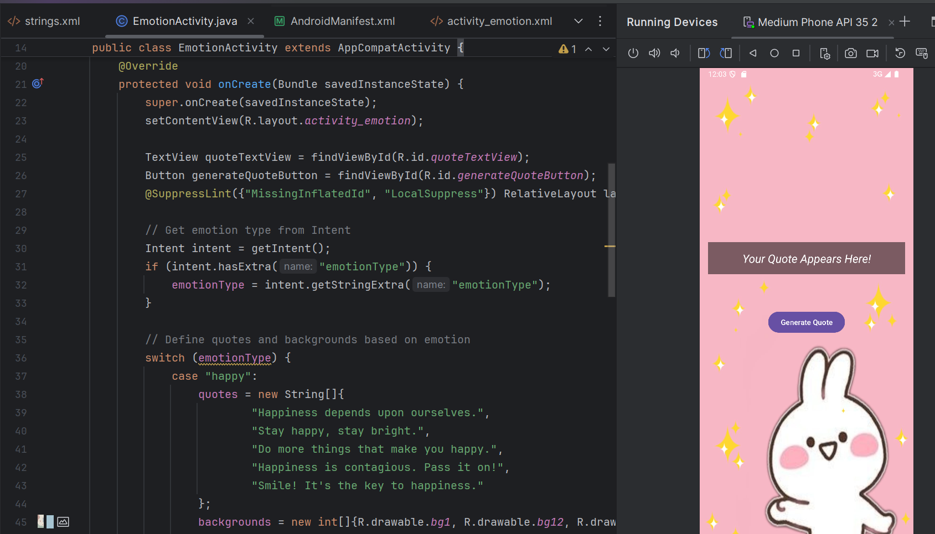

**String.xml:**

<resources>  
 <string name="app_name">Q_Motion</string>  
 <string name="q_motion"><b><u><i>Q-MOTION</i></u></b></string>  
 <string name="happy"><b><u>HAPPY</u></b></string>  
 <string name="sad"><b><u>SAD</u></b></string>  
 <string name="angry"><b><u>ANGRY</u></b></string>  
 <string name="overwhelmed"><b><u>OVERWHELMED</u></b></string>  
</resources>

**Output:**

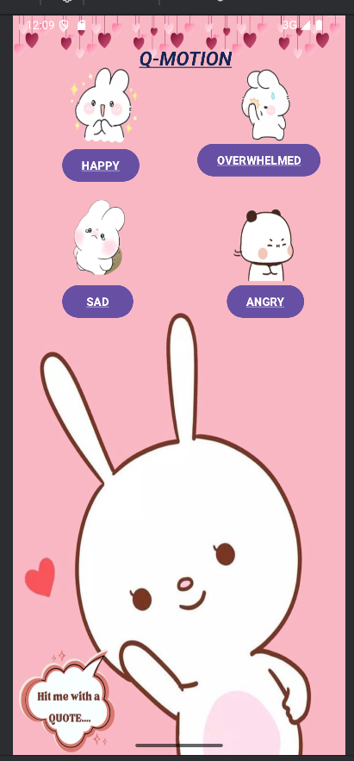 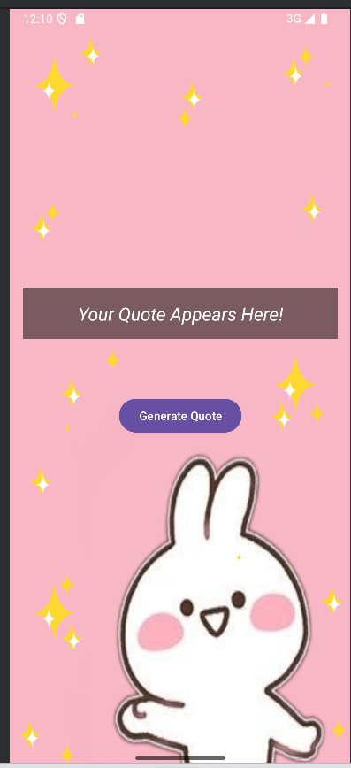

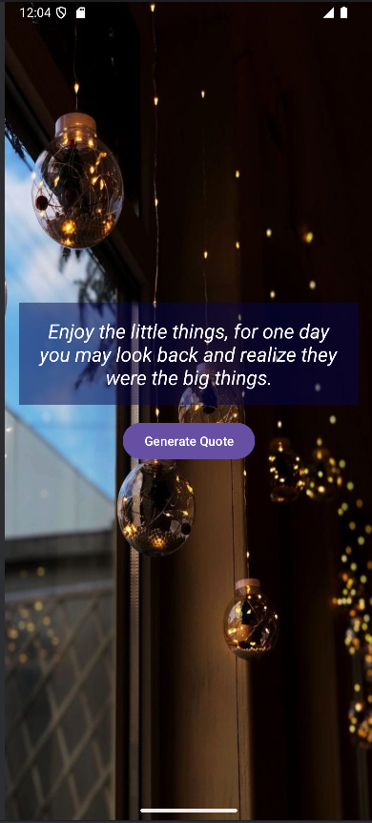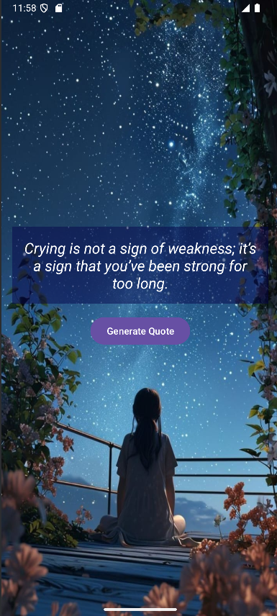

**Explaination:**

This is an Android app that helps users based on their emotions. It has four emotion buttons (Happy, Sad, Angry, and Overwhelmed). When a user clicks one of them, they go to a new screen where they can generate random motivational quotes related to their selected emotion. The background of the new screen also changes randomly to match the mood.

1. activity_main.xml (Main Screen Layout)

This is the first screen of the app. It has:

A title (Q-MOTION)

Four buttons for different emotions (Happy, Sad, Angry, Overwhelmed)

When the user clicks any of these buttons, it will take them to the next screen (Emotion Screen) with quotes.

2. MainActivity.java (Main Screen Logic)

This is the code behind the first screen.

It connects each button (happyButton, sadButton, etc.) to its ID from activity_main.xml.

It sets click listeners for each button. This means when a button is clicked, it:

Opens EmotionActivity.java (the next screen)

Sends which emotion the user clicked (like “happy” or “sad”)

Example:

If the user clicks the Happy button, it will start the EmotionActivity.java and pass "happy" as a message.

3. activity_emotion.xml (Emotion Screen Layout)

This is the second screen of the app, where the user sees a random quote.

It has a TextView (quoteTextView) to display the quote.

It has a Generate Quote button that, when clicked, shows a new random quote.

The background of this screen also changes based on the emotion.